 Supervised learning is where you have input variables (x) and an output variable (Y) and you use an algorithm to learn the mapping function from the input to the output Y = f(X) . The goal is to approximate the mapping function so well that when you have new input data (x) that you can predict the output variables (Y) for that data.

Supervised learning problems can be further grouped Classification and Regression.

The difference between the two tasks is the fact that the dependent attribute is numerical for regression and categorical for classification.

What is Regression:A regression problem is when the output variable is a real or continuous value, such as “salary” or “weight”.

Types of Regression problems :

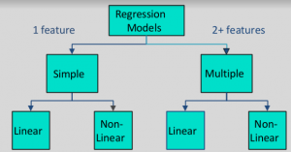

Which of the following is a regression task?

* Predicting age of a person
* Predicting nationality of a person
* Predicting whether stock price of a company will increase tomorrow

**Terminologies Related to the Regression Analysis:**

* **Dependent Variable:** The main factor in Regression analysis which we want to predict or understand is called the dependent variable. It is also called **target variable**.
* **Independent Variable:** The factors which affect the dependent variables or which are used to predict the values of the dependent variables are called independent variable, also called as a **predictor**.
* **Outliers:** Outlier is an observation which contains either very low value or very high value in comparison to other observed values. An outlier may hamper the result, so it should be avoided.
* **Multicollinearity:** If the independent variables are highly correlated with each other than other variables, then such condition is called Multicollinearity. It should not be present in the dataset, because it creates problem while ranking the most affecting variable.
* **Underfitting and Overfitting:** If our algorithm works well with the training dataset but not well with test dataset, then such problem is called **Overfitting**. And if our algorithm does not perform well even with training dataset, then such problem is called **underfitting**.

Why do we use Regression Analysis?

* Regression estimates the relationship between the target and the independent variable.
* It is used to find the trends in data.
* It helps to predict real/continuous values.
* By performing the regression, we can confidently determine the most important factor, the least important factor, and how each factor is affecting the other factors.

Types of Regression

* **Linear Regression**
* **Logistic Regression**
* **Polynomial Regression**
* **Support Vector Regression**
* **Decision Tree Regression**
* **Random Forest Regression**
* **Ridge Regression**
* **Lasso Regression:**

**Linear Regression/Multiple Linear Regression:**

* Linear regression shows the linear relationship between the independent variable (X-axis) and the dependent variable (Y-axis), hence called linear regression.
* If there is only one input variable (x), then such linear regression is called **simple linear regression**. And if there is more than one input variable, then such linear regression is called **multiple linear regression**.
* The relationship between variables in the linear regression model can be explained using the below image. Here we are predicting the salary of an employee on the basis of **the year of experience**.

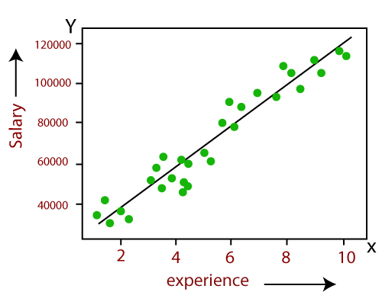

Y= aX+b

Here, Y = dependent variables (target variables),  
 X= Independent variables (predictor variables),  
 a and b are the linear coefficients

Some popular applications of linear regression are:

* Analyzing trends and sales estimates
* Salary forecasting
* Real estate prediction
* Arriving at ETAs in traffic.

**Polynomial Regression:**

* Polynomial Regression is a type of regression which models the **non-linear dataset** using a linear model.
* It is similar to multiple linear regression, but it fits a non-linear curve between the value of x and corresponding conditional values of y.
* Suppose there is a dataset which consists of datapoints which are present in a non-linear fashion, so for such case, linear regression will not best fit to those datapoints. To cover such datapoints, we need Polynomial regression.
* I**n Polynomial regression, the original features are transformed into polynomial features of given degree and then modeled using a linear model.** Which means the datapoints are best fitted using a polynomial line.

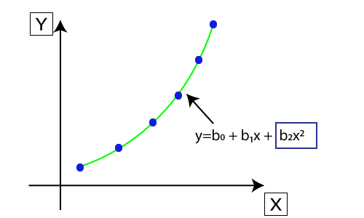

* The equation for polynomial regression also derived from linear regression equation that means Linear regression equation Y= b0+ b1x, is transformed into Polynomial regression equation Y= b0+b1x+ b2x2+ b3x3+.....+ bnxn.
* Here Y is the **predicted/target output, b0, b1,... bn are the regression coefficients**. x is our **independent/input variable**.
* The model is still linear as the coefficients are still linear with quadratic.

**What is Regularization :**

* It is a technique to prevent the model from overfitting by adding extra information to it.
* Sometimes the [machine learning](https://www.javatpoint.com/machine-learning) model performs well with the training data but does not perform well with the test data. It means the model is not able to predict the output when deals with unseen data by introducing noise in the output, and hence the model is called overfitted. This problem can be deal with the help of a regularization technique.
* This technique can be used in such a way that it will allow to maintain all variables or features in the model by reducing the magnitude of the variables. Hence, it maintains accuracy as well as a generalization of the model.
* Regularization works by adding a penalty or complexity term to the complex model.
* It mainly regularizes or reduces the coefficient of features toward zero. In simple words, "In regularization technique, we reduce the magnitude of the features by keeping the same number of features."

**Techniques of Regularization**

There are mainly two types of regularization techniques, which are given below:

* Ridge Regression
* Lasso Regression

**Ridge Regression:**

* A general linear or polynomial regression will fail if there is high collinearity between the independent variables, so to solve such problems, Ridge regression can be used.
* Ridge regression is one of the most robust versions of linear regression in which a small amount of bias is introduced so that we can get better long term predictions.
* The amount of bias added to the model is known as Ridge Regression penalty. We can compute this penalty term by multiplying with the lambda to the squared weight of each individual features.
* Ridge regression is a regularization technique, which is used to reduce the complexity of the model. It is also called as L2 regularization.
* It helps to solve the problems if we have more parameters than samples.

**Lasso Regression:**

* It is similar to the Ridge Regression except that penalty term contains only the absolute weights instead of a square of weights.
* Since it takes absolute values, hence, it can shrink the slope to 0, whereas Ridge Regression can only shrink it near to 0.
* It is also called as L1 regularization.

**Key Difference between Ridge Regression and Lasso Regression**

* **Ridge regression** is mostly used to reduce the overfitting in the model, and it includes all the features present in the model. It reduces the complexity of the model by shrinking the coefficients.
* **Lasso regression** helps to reduce the overfitting in the model as well as feature selection.